Autonomous Theory Discovery using Foundation Models

Abstract—AI systems have shown high competencies in areas such as research literature comprehension, text generation, code generation, and solving pre-defined problems. In contrast, scien-tific discoveries rely mostly on researchers for detecting unknown problems, creating hypotheses, experimenting, interpreting re-sults, and refining their theories. In this work, an Autonomous Theory Discovery Framework is introduced that attempts to move beyond AI support for researchers to autonomous theory or algorithm discovery and improvement. The proposed framework combines foundation models, knowledge graphs, a hypothesis generation engine, world models, automatic experimentation, and mathematical/statistical verification processes.
First, research analysis is done and connections between the discovered knowledge are found. Then, novel hypotheses are generated and formulated into theories or algorithms. With the help of the world model, possible outcomes are predicted and the framework automatically generates and runs the experimental code. Finally, experimental results are verified mathematically and statistically, allowing the rejection of unsatisfactory hypothe-ses and refinement of the promising ones. Through self-reflection and iteration, the proposed framework attempts to constantly improve its theory suggestions. For the current research, the focus is on AI/ML research as a first domain for testing the sug-gested framework, trying to answer the question of whether the framework, based on foundation models, allows for autonomous creation, testing, rejection, refinement, and improvement of scientific theories.
Index Terms—Autonomous Theory Discovery, Foundation Models, Knowledge Graphs, Hypothesis Generation, World Mod-els, Automated Experimentation, Mathematical Verification, Sta-tistical Verification, Self-Reflection, Scientific Discovery

- Introduction
Recent years saw the evolution of AI systems from tools specialized for particular prediction and analysis tasks to more autonomous systems that enable the execution of complicated scientific workflows. The process of scientific discovery has always relied on human expertise, human intuition, analysis of literature, making hypotheses, experimenting, and inter-preting the results of experiments. While computer-based and machine-learning methods have sped up certain steps of the process, the increased size and complexity of scientific data have made it hard to systematically explore a large space of
hypotheses and tie together all the steps of discovery. Recent progress in large language models, foundation models, agentic AI, symbolic methods, and scientific computing opens up new opportunities for creating AI systems that will be able to assist in various steps of scientific research, from making hypotheses to running experiments and their analysis [1][2][3][4]. Re-search in AI for science also shows that generative models are able to go beyond choosing from existing candidates to generating new structures, equations, models, and explanations [5][6][7].
One such emerging path is that of autonomous scientific discovery, where AI models can explore scientific questions in an iterative and increasingly independent manner. Language models may offer the ability to reason, plan, use tools, and integrate knowledge, whereas external databases, simulation tools, symbolic reasoning systems, and automated experimen-tation platforms can enable ways of testing the proposed hy-potheses [1][2]. Information retrieval and augmentation along with knowledge representation can aid in gathering scientific information that already exists, whereas the mechanism for hypothesis generation and testing may offer new potential explanations [1][3]. Automated equation discovery studies show how crucial it is to combine the generation of candidates with mathematical consistency checks, physical constraints, statistical evaluations, and experimental evidence instead of basing everything on predictive performance [4][6]. Moreover, materials discovery studies can offer insights into how gen-erative models, foundation models, synthesis planning, and experimental feedback can be connected for building closed-loop discovery systems [8]. Studies on the topic of foundation world models indicate how interpretable representations and predictive models can enable data-efficient reasoning about future states of the system, which is yet another direction towards autonomous science [9][10].
The research under consideration is focused on the creation of an Autonomous Theory Discovery Framework that would allow to develop a process that would allow AI to investigate, produce, assess and improve scientific theories or algorithms in an automated way minimizing the need of continuous human input. The proposed framework is aimed to integrate

foundation models with the scientific knowledge acquisition, hypothesis formulation, mathematical and symbolic reasoning, experimentation or simulation, statistical assessment and self-improvement. In such a way, the system would be able to start from a scientific problem, assess existing knowledge on the matter, create some hypotheses or theoretical model and use some computational means to verify whether the hypotheses and theories can be consistent and explain the problem. Next, promising hypotheses can be verified with the help of some simulations or experimentations and unproductive hypotheses can be excluded or revised taking into account the result that was achieved. In addition, a system of persistent memory that would store previous hypotheses, experiments, success and failures would allow accumulating experience and exclude re-implementation of unproductive strategies [1][2][3]. It is evident, therefore, that the main goal of the research in question is not only assistance in some scientific problems, but also
- Background and Literature Survey
A summary of the existing research work related to autonomous scientific discovery, foundation models, scien-tific agents, hypothesis generation, automated theory discov-ery, foundation-model-based evaluation, materials discovery, robotics, and world models is presented in Table I.
- Problem Statement
Scientific discovery has historically relied on the role of human scientists to recognize and define problems, gather information about current scientific knowledge, develop hy-potheses, perform experiments, analyze results, and refine scientific theories in many cycles. Even though recent de-velopment in artificial intelligence, foundation models, and scientific agents has made it possible to automate some of the aforementioned individual research tasks, the current systems still often operate within a certain stage or domain of scientific activity. Recent research discusses challenges associated with exploring a large space of hypotheses, generating scientifi-cally valuable hypotheses, knowledge integration, conducting experiments, and verifying if the results obtained are actu-ally new, consistent, and reproducible. Thus, an Autonomous Theory Discovery Framework which can effectively combine knowledge acquisition, hypothesis generation, theory creation, computational or experimental verification, mathematical and statistical validation, and further theory refinement is needed. The objective of this research is to build an AI system that can operate autonomously, that is generate candidates for theories, test their consistency and compatibility with scientific princi-ples and evidence, discard inappropriate hypotheses and refine good candidates through iteration without constant human intervention.
- Proposed System Architecture
The above Autonomous Theory Discovery Framework will be designed as an integrated and closed-loop system that is composed of the following components; foundation models,
scientific knowledge sources, hypothesis generators, theory representation, computation, experiments, validation, and per-sistent memory. The system receives the defined scientific problem by the user along with related literature, database, experiments and simulation tools. The knowledge acquisition and retrieval component will organize all available knowledge for delivery to the hypothesis generator component, which generates the potential scientific hypotheses. These hypotheses are transformed into formal/symbolic form and are evaluated using mathematical reasoning and domain constraints. They are validated via simulation or experimentation followed by analysis of their results through statistical and scientific vali-dation techniques.

A. Architecture Overview
The system architecture comprises interconnected modules corresponding to the key steps of the autonomous scientific discovery process. First, the Knowledge Acquisition and Re-trieval module gathers relevant information from scientific literature, structured databases, empirical observations, and computer resources. This information is further processed by the Hypothesis Generation module where a foundation model establishes relevant relations and suggests hypotheses. The Theory Representation and Reasoning module converts the suggested hypotheses into mathematical/symbolic form and verifies their consistency with the existing scientific knowledge and specific domain limitations. The Experimenta-tion/Simulation module performs evaluations of the suggested theories via computer experiments, simulations, or use of external scientific tools. Finally, the Evaluation and Validation module processes the acquired results and decides about acceptance/rejection/refinement of a particular hypothesis.
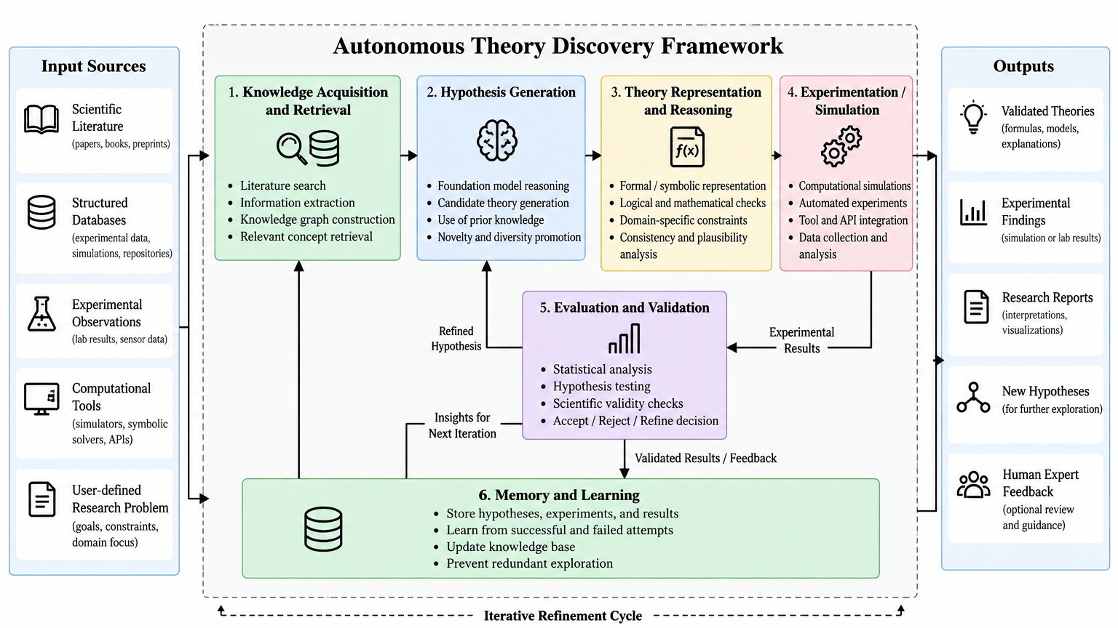
Fig. 1. Proposed System Architecture

The Memory and Learning module stores the data related to previous hypotheses, experimentations, failures and successes achieved. Persistent memory makes the system learn from the past, not try again the methods which were unsuccessful in the past and use the accumulated data while performing further discovery cycles. Therefore, the whole system works as an iterative closed loop, and not as a one-way process. If a hypothesis fails to pass the validation stage, then the evidence supporting it is passed back to the system using the memory and learning functionality and is used to create a new hypothesis. If a hypothesis fulfills all the requirements

TABLE I
Literature Survey of Autonomous Scientific Discovery and Foundation Model Systems

S.No | Paper Name | Year & Author | Method Used | Dataset Used | Accuracy / Per-formance | Merits | Demerits
1 | From AI for Science to Agentic Science: A Survey on Autonomous Scientific Discovery | 2025 – J. Wei et al. | Domain-oriented framework for Agentic Science covering planning and reasoning, tool use, memory, multi-agent collaboration, optimization, and a four-stage scientific discovery workflow | Multiple scientific stud-ies across life sciences, chemistry, materials sci-ence, physics, and astron-omy | Survey study; no single accuracy value | Provides a comprehensive framework for autonomous scientific discovery and con-nects scientific capabilities, processes, and domain appli-cations | Scientific reproducibility, novelty validation, transparency, safety, and reliable autonomous decision-making remain challenging
2 | Autonomous Agents for Scientific Discovery: Orchestrating Scien-tists, Language, Code, and Physics | 2026 – L. Zhou et al. | LLM-based scientific agents that coordinate human knowledge, natural language, code, computational tools, and scientific workflows across hypothesis generation, experimentation, analysis, and refinement | Multiple scientific  domains and  computational discovery workflows | Survey and con-ceptual analysis; no single accu-racy reported | Demonstrates how scientific agents can integrate reason-ing, tool use, code execu-tion, and iterative research processes | Current systems still face limitations in reliability, gen-eralization, autonomy, scien-tific grounding, and integra-tion with real-world experi-ments
3 | AI-Generated Hypotheses and the Emergence of Autonomous Scien-tific Discovery | 2026 – T. J. Jacobs-son | AI-assisted hypothesis generation using LLMs, scientific literature,  databases, memory, simulation tools, and agentic workflows; proposes Hypothesis-Driven Autonomous Discovery Systems (HADS) | Scientific literature, exter-nal databases, computa-tional simulations, and ex-perimental workflows | Conceptual review; no single accuracy reported | Identifies hypothesis genera-tion as a critical stage and provides criteria such as nov-elty, usefulness, plausibility, falsifiability, and actionabil-ity | LLMs may generate inaccu-rate or biased hypotheses and remain limited by physical understanding, prompt sensi-tivity, and knowledge inher-ited from training data
4 | Automated Scientific Discovery: From Equation Discovery to Au-tonomous Discovery Systems | 2026 – S. Kramer, M. Cerrato, J. Brugger, S. Dzˇeroski, R. D. King | Survey of equation discovery, symbolic regression, neural-guided discovery, closed-loop scientific systems, causal discovery, and different levels of scientific autonomy | Equation-discovery datasets, scientific observations, simulations, and experimental systems discussed across the literature | Survey study; no single accuracy reported | Connects interpretable sci-entific knowledge discovery with automation and auton-omy and identifies the need for systems that communi-cate results in scientific for-malisms | Few existing systems combine high autonomy with interpretable, scientifically communicable theories and causal understanding
5 | From Prediction to Discovery: A Review of Scientific Discovery with Foundation Models | 2026 – T. Wang | Four-mode taxonomy of foundation models as predictive surrogates, generative designers, autonomous agents, and objects of discovery | Protein, genomic,  molecular, materials,  Earth-science, and mathematical datasets and benchmarks | Survey study; performance depends on individual applications | Distinguishes prediction from genuine discovery and emphasizes external validation, causal evidence, and auditable scientific outputs | Hallucination, data leakage, benchmark contamination, limited reproducibility, and difficulty validating whether model outputs represent genuine discovery
6 | Autonomous Discovery of Particle Physics Theories from Experimen-tal Data | 2026 – S. Alexan-der, B. Bradley, L. Gouskos, C. Niu | Albert, a neuro-symbolic framework combining a Transformer policy network, formal theory grammar, reinforcement learning, theoretical  consistency checks,  symbolic computation, and experimental likelihood evaluation | Legacy Large Electron–Positron Collider (LEP) precision electroweak measurements | Top-quark mass predicted as  178.9 ± 5.0  GeV; Higgs-  boson mass  predicted as  146.9 ± 17.4  GeV | Demonstrates autonomous theory generation  from experimental data while enforcing theoretical consistency and reducing free-form model hallucination | Focused on particle physics and a constrained theory space; computational com-plexity and broader gener-alization to other scientific domains remain open chal-lenges
7 | Automated Capability Discovery via Foundation Model Self-Exploration | 2025 – C. Lu, S. Hu,  J. Clune | Automated Capability Dis-covery (ACD), where one foundation model acts as a scientist to generate novel evaluation tasks for another foundation model and auto-matically evaluates the re-sults | Generated tasks evaluated on GPT-4o, Claude Son-net 3.5, and Llama3-8B | 1330 novel tasks discovered from 5000 generations for GPT-4o; automated evaluation achieved an F1 score of 0.86 against human judgments | Enables scalable discovery of previously unknown ca-pabilities and failure modes with reduced human effort and supports open-ended ex-ploration | Primarily evaluates model capabilities rather than scien-tific theories; generated tasks and results remain dependent on foundation-model behav-ior and automated judging
8 | AI for Accelerated Materials Dis-covery: From Generative Design to Autonomous Realization | 2026 – J. Choi, S.  Kim, J. Park, J. Choi,  S. An, Y. Jung | Generative materials design, physics-informed AI, mul-timodal foundation models, LLM-based agents, retrieval and tool grounding, syn-thesis planning, and self-driving laboratories | Crystal structures, mate-rials databases, spectro-scopic information, simu-lations, and experimental data | Review study; no single accuracy reported | Provides an end-to-end view connecting candidate generation, synthesis  planning, autonomous experimentation, feedback, and data provenance | Limited and heterogeneous databases, synthesis feasibil-ity, uncertainty, data quality, and the design–realization gap remain challenging
9 | Foundation Models for Autonomous Robots in Unstructured Environments | 2024 – H. Naderi, A. Shojaei, L. Huang | Systematic multi-  dimensional review  combining foundation models, robotics, and unstructured environments with deliberative acting theory | Literature covering foundation-model applications in robotics, construction, disaster management, and other unstructured environments | State-of-the-  art assessed  at conditional automation on a five-level autonomy scale; GPT-based models account for more than 44% of reported foundation- model usage | Provides a systematic bench-mark for understanding the use of foundation models in autonomous robotic systems and identifies pathways to-ward safer autonomy | Focuses primarily on robotics and unstructured environments; full autonomy remains limited by environmental uncertainty, observability, generalization, and safety requirements
10 | Zero-shot Safety Prediction for Au-tonomous Robots with Foundation World Models | 2024 – Z. Mao, S.  Dai, Y. Geng, I. Ruchkin | Training-free foundation world model using Segment Anything Model (SAM) for interpretable object representations and LLM-based prediction of future states | OpenAI Gym CartPole and LunarLander simulated environments; 10,000 test sequences per case study | Foundation world models outperform standard world models for safety prediction and show  performance comparable  to supervised methods without training data; safety evaluated using F1 score and false-positive rate | Provides interpretable state representations, reduces training-data requirements, and enables zero-shot safety prediction using foundation models | Longer prediction horizons increase errors; irrelevant segmented objects can increase computational cost, and performance depends on sufficient input context

for validation, then the system may come up with a validated theory or a scientific discovery.

A. System Overview
- Methodology

B. Data Flow Diagram

The data flows begin with the research problem and sup-portive data including scientific literature, databases, observed data, and simulation data. Knowledge Acquisition and Re-trieval module will process this input and extract the useful information, concepts, relations, and scientific constraints. The extracted knowledge will be provided to the Hypothesis Generation module to generate the hypotheses. The generated hypotheses will be provided to the Theory Representation and Reasoning module to convert those hypotheses into formal or symbolic representation and evaluate the validity of those hypotheses. Valid hypotheses will be then provided to the Experimentation/Simulation module to perform computational experiments or simulation to get the evidence. This describes the knowledge acquisition, reasoning, tool usage, experimen-tation, and analysis as discussed in the autonomous scientific discovery papers.
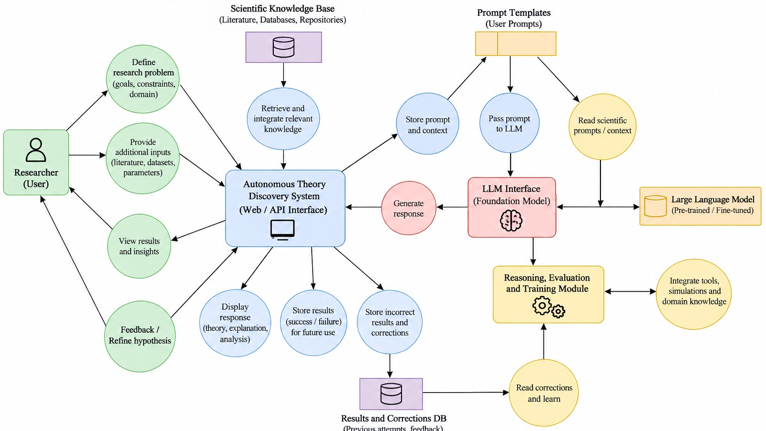
Fig. 2. Data Flow Diagram

The findings from the experiment or simulation are moved to the Evaluation and Validation component. The system evaluates the findings and determines whether the proposed hypothesis needs to be accepted, rejected, or modified. The findings and the relevant intermediate findings are recorded in the Memory and Learning component, which stores the acquired knowledge and makes it ready for the next discovery cycle. In case the hypothesis is rejected, the findings are used to modify or propose a new candidate, and the process goes on until another discovery cycle completes. In case the hypothesis meets all the required criteria of validation, the system gener-ates output in form of a validated theory, experiment findings, new hypotheses, or research report. Therefore, the entire
data flow can be depicted as follows: Research Problem → Knowledge Acquisition → Hypothesis Generation → Theory Representation and Reasoning → Experimentation/Simulation
→ Evaluation and Validation → Memory and Learning →
Refinement/Validated Theory.
In this regard, the design of an Autonomous Theory Discov-ery System would include developing a closed-loop method-ology that allows for the integration of the capabilities of artificial intelligence in helping with the process of scientific discovery starting from problem definition through theory val-idation. As part of the suggested methodology, the discovery process starts with the definition of the problem and collection of the existing scientific knowledge related to the area of investigation and obtained through literature review, databases, or any other source. This is followed by use of the foundation model that allows for retrieval of the required contextual knowledge, generation of the hypotheses and formulation of the theories. These generated hypotheses/theories are then evaluated on the basis of mathematical reasoning or any other simulation or computation experiment that tests consistency and possibility of validity of each hypothesis. The results of these experiments are evaluated scientifically/statistically and successful/unsuccessful attempts are recorded in a knowledge base.
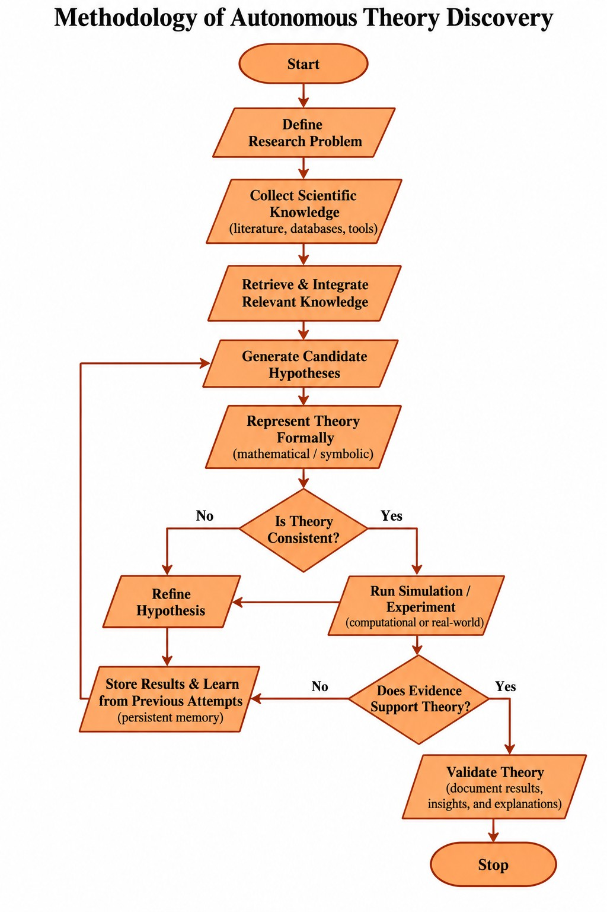
Fig. 3. Methodology Flowchart

B. Scientific Data Acquisition and Knowledge Preprocessing
The input to the proposed Autonomous Theory Discov-ery framework consists primarily of a scientific problem, research objectives, existing literature, structured scien-tific data, experimental observations, and computational resources. The researcher initially specifies the scientific goal together with relevant constraints and evaluation requirements. The system then collects supporting information from sci-entific publications, databases, repositories, simulations, and other available sources. The retrieved information may contain

textual descriptions, numerical measurements, equations, ta-bles, experimental results, and structured scientific knowledge. A retrieval and preprocessing module filters the collected information, removes irrelevant or redundant content, and organizes the remaining information into a form suitable for subsequent reasoning. Knowledge graphs or other structured representations can be used to connect entities, properties, relationships, and previously established findings. This stage is important because scientific knowledge is heterogeneous and may contain information from different data formats and sources.
The relevance of a retrieved scientific item can be repre-sented using a retrieval score:

S(d, q) = f_{rel}(d, q) (1)
where,
- d = Scientific document, observation, or knowledge item
- q = User-defined scientific problem or research query
- f_{rel}(·) = Relevance estimation function
- S(d, q) = Relevance score between the knowledge item and the query
The highest-relevance information is retained as contextual knowledge for the discovery process. This approach allows the system to ground subsequent reasoning in available scientific evidence rather than relying only on the internal knowledge of a foundation model. The use of retrieval, knowledge struc-turing, and persistent scientific memory is consistent with the autonomous discovery workflow discussed in the literature.
C. Hypothesis Generation and Theory Formulation
Hypothesis generation represents the central discovery stage of the proposed framework. After the relevant scientific knowl-edge has been assembled, a foundation model analyzes the research problem, available evidence, previous findings, and scientific constraints to propose candidate hypotheses. Instead of generating a single answer, the system can construct mul-tiple candidate explanations and prioritize them according to factors such as relevance, novelty, plausibility, testability, and potential scientific value. External tools, scientific databases, simulations, and domain-specific models can be incorporated when additional evidence is required. The candidate hypothe-ses are subsequently converted into a structured representation so that they can be evaluated systematically.
The selection of a promising hypothesis can be represented as:
h∗ = arg max P (h | K, C) (2)
h∈H
where,
- H = Set of candidate hypotheses
- h = Individual candidate hypothesis
- h∗ = Selected hypothesis
- K = Retrieved and structured scientific knowledge
- C = Scientific constraints and research objectives
- P (h | K, C) = Estimated suitability of hypothesis h
The selected hypothesis is then expressed as a formal theory, mathematical relationship, symbolic model, algorithm, or other domain-appropriate representation. Formal representa-tion makes it possible to perform mathematical reasoning and automated consistency checks before expensive experimenta-tion is attempted. This stage is particularly important because recent autonomous discovery research emphasizes the need to move from hypothesis generation toward theories that are testable and scientifically meaningful.
D. Automated Experimentation, Evaluation, and Iterative Re-finement
After a candidate theory has been formulated and checked for consistency, the system performs computational experi-ments, simulations, or available scientific evaluations to deter-mine whether the theory agrees with observed evidence. The experimentation module can select suitable tools, construct experimental workflows, execute simulations or analyses, and collect the resulting observations. Where multiple candidate theories are available, the system can prioritize experiments that provide useful information for distinguishing between competing hypotheses. Both successful and failed experiments are retained because unsuccessful attempts can provide useful constraints for subsequent discovery cycles.
The evaluation of a candidate theory can be represented by a combined validation function:

E(h) = w₁C(h) + w₂F (h) + w₃R(h) + w₄N (h) (3)
where,
- E(h) = Overall evaluation score of hypothesis h
- C(h) = Consistency with scientific and mathematical constraints
- F (h) = Agreement with experimental or simulated find-ings
- R(h) = Reproducibility or reliability of the obtained result
- N (h) = Novelty of the proposed hypothesis
- w₁, w₂, w₃, w₄ = Weights assigned to the evaluation criteria
If the obtained evidence does not sufficiently support the candidate theory, the system stores the result and uses the associated feedback to modify or generate another hypothesis. If the evidence satisfies the required criteria, the theory is retained as a validated candidate and its supporting results are documented. A persistent memory mechanism records hy-potheses, experimental configurations, observations, failures, successful results, and reasoning information so that future iterations can benefit from previous attempts. The complete process therefore forms a closed loop of knowledge ac-quisition, hypothesis generation, theory formulation, ex-perimentation, evaluation, memory, and refinement. This iterative organization is consistent with the scientific-agent workflows described across the literature, while the use of ex-ternal validation helps distinguish potential scientific discovery from unsupported model-generated outputs.

The final workflow enables the proposed system to sup-port scientific knowledge retrieval, hypothesis generation, formal theory construction, automated experimentation, mathematical and statistical evaluation, persistent learn-ing, and iterative theory refinement within a unified au-tonomous discovery framework. The methodology can be extended with domain-specific simulators, symbolic reasoning systems, automated laboratory platforms, world-model-based prediction, and human expert review where required. Such extensions are particularly relevant because existing research indicates that reliable autonomous discovery requires not only candidate generation but also rigorous validation, provenance, reproducibility, and mechanisms for learning from both suc-cessful and unsuccessful attempts.
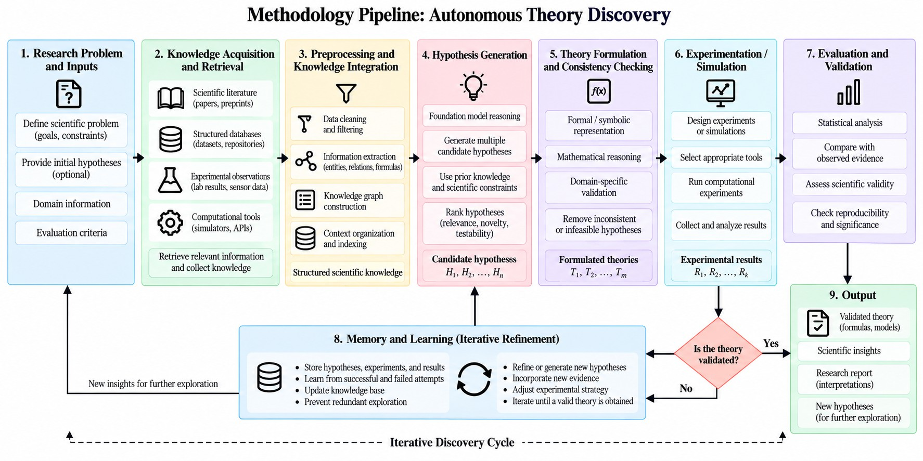

Fig. 4. Methodology Pipeline

- Implementation
- System Implementation Architecture
The suggested Autonomous Theory Discovery Framework

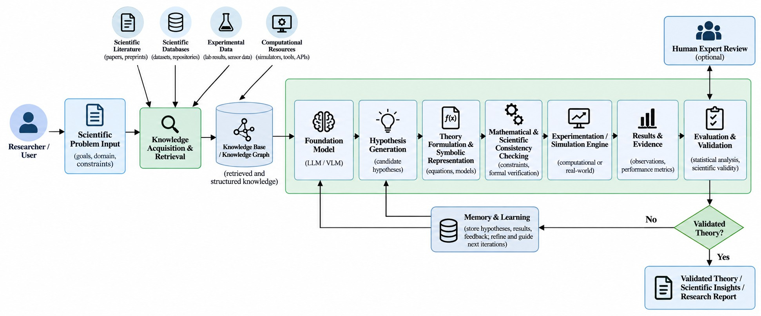

Fig. 5. Implementation Architecture Diagram

- Scientific Problem Acquisition and Data Preprocessing
The proposed Autonomous Theory Discovery system be-gins with the definition of a scientific problem supplied by the researcher. The input may include a research question, experimental observations, numerical measurements, scientific datasets, previously established equations, domain constraints, and relevant research literature. The system first identifies the type and structure of the available information and converts heterogeneous inputs into a standardized representation. Tex-tual scientific information is cleaned and segmented, numerical observations are normalized when required, and experimental or simulation data are checked for missing, inconsistent, or irrelevant values. Relevant literature and scientific records are then organized so that they can be accessed during subse-quent reasoning stages. This preprocessing stage provides the foundation for automated knowledge retrieval and hypothesis generation.
The normalization of a numerical observation can be repre-sented as:

can be implemented following a pipeline-based approach where the links between scientific input, knowledge pro-cessing, reasoning of the foundation model, theory genera-tion, computational validation, and learning are formed. This

where,
X − X_{min}
X_{n} =
Xmax − Xmin
(1)

process is initiated via the Researcher Interface, where a user specifies a scientific problem, objective, constraints, or experimental observations. Next, the Scientific Knowledge Layer extracts related data from the scientific papers, scientific databases, equations, datasets, and stored discoveries. The acquired information is then processed and fed to the Foun-dation Model, which serves as the main module responsible for the problem interpretation and generation of hypotheses. These hypotheses are delivered to the Theory Generation and Symbolic Reasoning Module to be formulated as structured mathematical/ logical expressions and verified in accordance with certain scientific criteria. Then, the link between the candidate theory and Simulation and Computational Exper-iments Modules is established to generate evidence to test this theory. Observations obtained from this stage are further analyzed by the Theory Evaluation and Validation Module according to the criteria of consistency, predictive agreement, novelty, and reproducibility. Successful candidates are saved as potential discoveries, while failed candidates are returned to the improvement loop.
  - X = Original scientific observation
  - X_{min} = Minimum value of the observation range
  - X_{max} = Maximum value of the observation range
  - X_{n} = Normalized observation
The preprocessing mechanism produces a consistent repre-sentation of the available scientific evidence. The processed information is subsequently passed to the knowledge retrieval and reasoning components, where it can be combined with information obtained from scientific literature, databases, and previous discovery records.
- Scientific Knowledge Retrieval and Representation
The knowledge retrieval component provides the foundation model with scientific information relevant to the specified research problem. Instead of depending exclusively on in-formation encoded within the model, the system retrieves supporting material from scientific publications, structured databases, experimental records, mathematical resources, and the persistent discovery repository. Retrieved information is ranked according to its relevance to the current problem and

transformed into a structured contextual representation. Equa-tions, observations, relationships, constraints, and previously investigated hypotheses can be retained as separate knowledge elements. This representation allows the reasoning component to distinguish between established information and newly generated hypotheses.
The relevance of a knowledge item can be represented by:

S(d, q) = f_{rel}(d, q) (2)

where,
  - d = Retrieved scientific knowledge item
  - q = Current scientific problem
  - f_{rel}(·) = Relevance estimation function
  - S(d, q) = Relevance score
The most relevant information is supplied to the reasoning
E. Theory Construction and Scientific Reasoning
The theory construction module converts promising hy-potheses into structured scientific representations that can be evaluated computationally. Depending on the application domain, a candidate may be represented as a mathematical equation, symbolic expression, physical model, algorithmic formulation, or set of scientific relationships. A reasoning en-gine examines the generated representation against predefined domain rules, mathematical constraints, known observations, and available scientific evidence. Candidates that violate es-sential constraints are removed from further experimentation, while candidates satisfying the preliminary checks are for-warded for computational testing.
For a candidate theory h, preliminary consistency can be represented as:

model as context. Information generated during earlier discov-ery cycles is also considered when appropriate, allowing the system to use previous successful and unsuccessful attempts
C(h) = 1, if h satisfies the required constraints
0, otherwise
{︄
(4)

rather than repeatedly exploring the same possibilities.

- Hypothesis Generation Implementation
The hypothesis generation module is the primary discovery component of the proposed system. It receives the scientific problem, retrieved knowledge, experimental evidence, domain constraints, and previous discovery records. A foundation model analyzes these inputs and produces multiple candidate hypotheses that could potentially explain the observed phe-nomenon or solve the specified scientific problem. Rather than directly selecting the first generated explanation, the system maintains a collection of candidate hypotheses and evaluates them according to their relevance, plausibility, novelty, testa-bility, and compatibility with available evidence.
The candidate selection process can be represented as:

h∗ = arg max [w₁P (h) + w₂N (h) + w₃T (h) + w₄C(h)]
This stage helps prevent unrestricted generation of theories that cannot be represented or evaluated within the selected scientific domain. The use of formal representations also makes the resulting hypotheses easier to inspect, compare, reproduce, and validate.

- Simulation and Automated Experimentation
After preliminary validation, the candidate theory is evalu-ated using available computational experiments, simulations, numerical procedures, or external scientific tools. The ex-perimentation module converts the theory into an executable evaluation procedure and produces predicted observations. These predictions are compared with experimental or refer-ence observations to determine how effectively the candidate explains the available evidence. When several candidates are being considered, the system can evaluate them under compa-rable conditions and retain the evidence associated with each candidate.

where,
h∈H
(3)
The prediction error for a numerical evaluation can be expressed as:

  - H = Set of generated hypotheses
  - h = Individual candidate hypothesis
∗

Epred
N
= |y_{i}
1 ∑︂
N

— yˆ_{i}| (5)

  - h = Selected candidate
  - P (h) = Plausibility score
  - N (h) = Novelty score
  - T (h) = Testability score
  - C(h) = Scientific consistency score
  - w₁, w₂, w₃, w₄ = Weights assigned to the evaluation criteria
The selected candidates are forwarded to the theory con-struction component. This allows the framework to explore several possible explanations before committing computational resources to detailed testing.
i=1

where,
  - N = Number of evaluated observations
  - y_{i} = Observed scientific value
  - yˆ_{i} = Value predicted by the candidate theory
  - E_{pred} = Average prediction error
The evaluation is not restricted to prediction error alone. Depending on the scientific problem, additional criteria such as theoretical consistency, experimental agreement, simplicity, novelty, and reproducibility can be considered.

- Theory Evaluation and Validation
The validation module determines whether a generated theory provides sufficient evidence to be considered a promis-ing scientific result. The candidate is evaluated using the results obtained from simulations or experiments together with mathematical constraints and available scientific knowledge. A composite evaluation score can be defined as:

V (h) = αC(h) + βA(h) + γN (h) + δR(h) (6)
where,
  - V (h) = Overall validation score
  - C(h) = Mathematical and scientific consistency
  - A(h) = Agreement with observed evidence
  - N (h) = Novelty of the candidate
  - R(h) = Reproducibility or reliability of the result
  - α, β, γ, δ = Relative importance weights
If the candidate achieves the required validation criteria, it is retained as a promising theory and its supporting evidence is recorded. If the result is insufficient, the candidate is marked for rejection or refinement. This separation between generation and validation is important because a generated hypothesis should not be considered a scientific discovery solely because it is plausible or well formulated.
- Discovery Memory and Iterative Refinement
The discovery memory module maintains a persistent record of the scientific discovery process. It stores generated hypothe-ses, theory representations, experimental configurations, pre-dicted results, observed results, rejected candidates, validation outcomes, and successful discoveries. The stored information is used during subsequent iterations to improve hypothesis generation and reduce unnecessary repetition. When a candi-date fails an evaluation, the associated evidence is returned to the reasoning stage so that the system can modify the hypothesis or explore an alternative explanation.
The iterative update can be represented as:

sectionSystem Output and Implementation Workflow
The final stage produces a structured discovery record con-taining the selected theory, supporting observations, evaluation results, assumptions, constraints, and relevant experimental or simulation evidence. The system can also provide re-jected hypotheses and their corresponding reasons when such information is required for scientific analysis. This makes the output more useful for human researchers because the result is accompanied by the evidence and reasoning process used during its development. The complete implementation therefore integrates scientific problem acquisition, knowl-edge retrieval, hypothesis generation, theory construction, symbolic reasoning, computational experimentation, vali-dation, persistent memory, and iterative refinement into a unified autonomous discovery pipeline.
- Results and Discussion
- Results
The proposed Autonomous Theory Discovery Frame-work is evaluated according to multiple criteria associated with the scientific discovery process. Since the framework performs hypothesis generation, theory construction, compu-tational evaluation, validation, and iterative refinement, its effectiveness is represented using hypothesis quality, theory consistency, prediction agreement, novelty, and reproducibility. The evaluation values shown below are illustrative and are in-tended to demonstrate the presentation format of the proposed system. They should be replaced with actual experimental measurements obtained after implementing and testing the framework.

TABLE II
Illustrative Performance Evaluation of the Proposed
Framework
Evaluation Criterion | Score (%)
Hypothesis Quality | 86
Theory Consistency | 91
Prediction Agreement | 88
Novelty | 82
Reproducibility | 85

where,
H_{t+1} = F (H_{t}, E_{t}, M_{t}) (7)

  - Performance Evaluation: The results indicate that theory consistency achieves the highest illustrative score, suggesting

    - H_{t} = Hypotheses considered during iteration t
    - E_{t} = Evidence obtained during iteration t
    - M_{t} = Knowledge stored in discovery memory
    - F (·) = Hypothesis refinement function
    - H_{t+1} = Updated hypothesis set for the next iteration The process continues until a candidate satisfies the prede-
fined scientific requirements or until the available computa-
tional or experimental resources are exhausted. The resulting workflow forms a closed discovery cycle in which scien-tific knowledge supports hypothesis generation, hypotheses are converted into testable theories, theories are evaluated through evidence, and the resulting feedback is used to guide subsequent discovery.
that the proposed validation mechanism can effectively check generated theories against predefined scientific constraints. Prediction agreement also represents a strong evaluation cri-terion because candidate theories can be compared with avail-able observations obtained from experiments or simulations. The novelty score is comparatively lower, indicating that expanding the hypothesis search space and improving the generation of scientifically original theories remain important areas for future development.
  - Graphical Performance Analysis: The bar graph demon-strates the relative performance of the proposed framework for hypothesis quality, theory consistency, prediction agreement, novelty, and reproducibility. Theory consistency obtains the

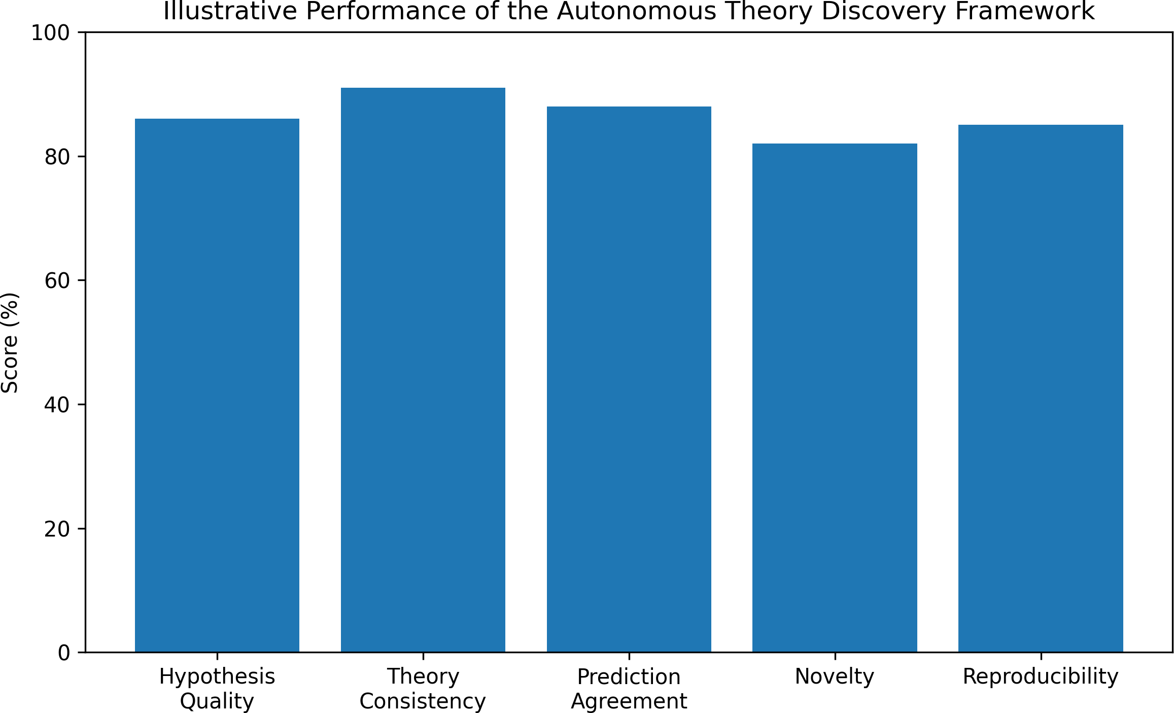

Fig. 6. Illustrative performance comparison of the Autonomous Theory Discovery Framework.

highest illustrative value, while novelty has the lowest value among the selected criteria. However, these values are only representative and should not be interpreted as measured experimental performance until the framework has been imple-mented and evaluated on an appropriate scientific benchmark.
  - Theory Candidate Analysis: The autonomous discovery process can generate several candidate theories during each discovery cycle. These candidates may either satisfy the vali-dation requirements, require additional refinement, or fail the defined scientific constraints. Table III presents an illustrative distribution of 100 candidate theories.

TABLE III
Illustrative Distribution of Generated Theory Candidates

Candidate Outcome | Number | Percentage
Validated | 45 | 45%
Refined | 35 | 35%
Rejected | 20 | 20%
Total | 100 | 100%

The candidate distribution demonstrates the iterative nature of the proposed system. A validated candidate can be retained as a promising scientific result, whereas candidates requir-ing refinement can be returned to the hypothesis-generation and theory-construction stages. Candidates that fail funda-mental scientific or computational checks can be rejected. This feedback-based mechanism enables the system to learn from unsuccessful attempts instead of treating every generated hypothesis as a valid discovery.
Figure 7 presents the candidate outcomes as a proportional distribution. The validated candidates represent the portion that satisfies the selected evaluation requirements, while refined candidates represent hypotheses that require additional rea-soning, experimentation, or adjustment. Rejected candidates correspond to theories that do not provide sufficient evidence or violate the defined constraints.
  - Overall Results: The proposed framework provides an integrated approach for performing autonomous scientific dis-covery through the combination of knowledge acquisition, hypothesis generation, theory formulation, reasoning, exper-

Fig. 7. Illustrative distribution of generated theory candidates according to their evaluation status.

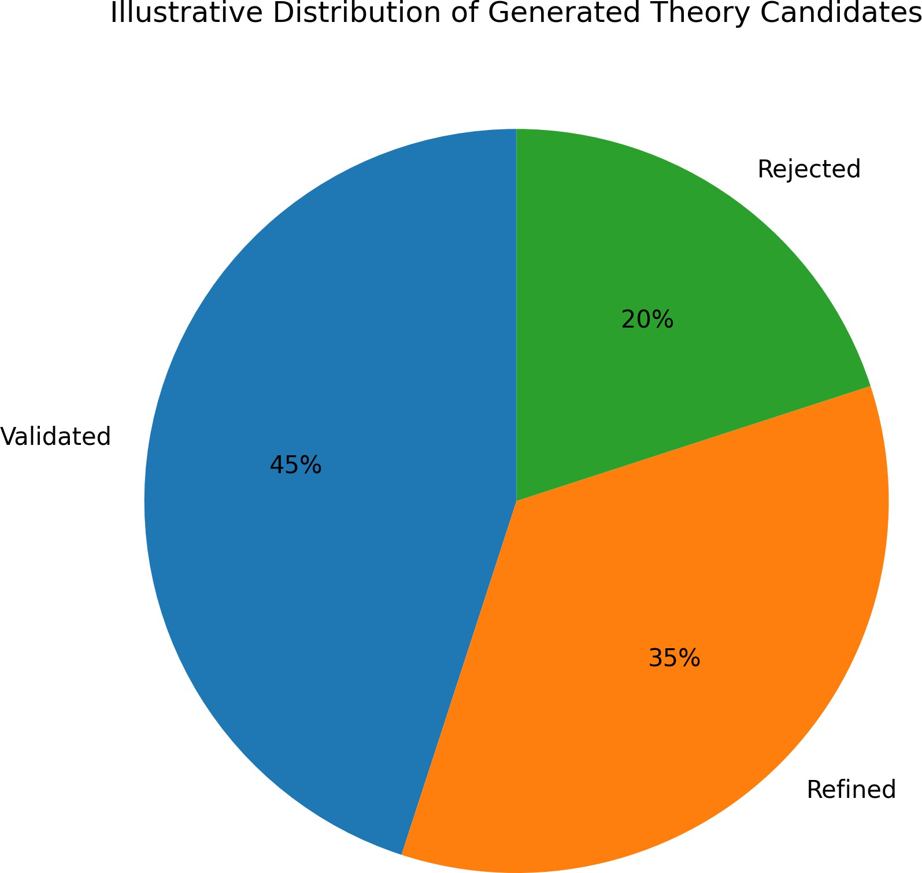
imentation, validation, and persistent memory. The use of an iterative feedback mechanism allows unsuccessful candidates to contribute information to subsequent discovery cycles. The evaluation framework also provides multiple dimensions for assessing a candidate theory rather than relying on a single performance measure. In the final implementation, these illus-trative values should be replaced with experimentally obtained measurements using a well-defined scientific problem, dataset, simulation environment, and validation procedure. This will provide an objective assessment of the framework’s ability to generate scientifically meaningful, testable, and reproducible theories.
- Discussions
From the results, it is clear that Visuolingo enables a cohesive manner of working with images by using different modalities. In this framework, there is a combination of image and video recognition, speech recognition and interaction, language processing, knowledge retrieval, multilingual com-munication, context and responses verification. Image-based applications can be addressed directly whereas video and speech recognition require extra processes that lead to an increase in the time taken to respond. With the inclusion of the processes of retrieving and verifying responses, better and reliable responses will be produced.
- Conclusion and Future Work
- Conclusion
The suggested Autonomous Theory Discovery Framework offers a systematic way for automating various phases of scientific discovery such as scientific knowledge acquisition, hypothesis generation, theory formation, reasoning, compu-tational experimentation, verification, and revision. Through linking the mentioned components within a feedback loop, the idea is to cut down the repeated human activity, but at the

same time provide a possibility of systematic exploration of all the potential scientific theories. Thanks to the introduction of discovery memory, the information collected during previous hypotheses, experiments, and verifications can be used within future discovery iterations.

- Future Work
In future research, efforts will be directed towards enhancing the capability of the framework to hypothesize in an innovative way, carry out extensive mathematical and symbolic reasoning, and validate theories within broader scientific areas. The framework can be further developed by incorporating sophis-ticated scientific agents, specific domain simulators, effective information retrieval and grounding techniques, automatic experiment generation, enhanced memory and learning meth-ods, and improved novelty and reproducibility assessment. Autonomous operation of the framework, while still under the control of scientists, is another important direction that can be explored in future research. Evaluation of the system on real scientific data and experimental setups is another important task.

References
- Z. Mao, S. Dai, Y. Geng, and I. Ruchkin, “Zero-shot Safety Prediction for Autonomous Robots with Foundation World Models,” 2026.
- H. Naderi, A. Shojaei, and L. Huang, “Foundation Models for Au-tonomous Robots in Unstructured Environments,” 2024.
- J. Choi, S. Kim, J. Park, J. Choi, S. An, and Y. Jung, “AI for Accel-erated Materials Discovery: From Generative Design to Autonomous Realization,” Chemical Reviews, vol. 126, pp. 8644–8693, 2026.
- C. Lu, S. Hu, and J. Clune, “Automated Capability Discovery via Foundation Model Self-Exploration,” arXiv preprint arXiv:2502.07577, 2025.
- S. Alexander, B. Bradley, L. Gouskos, and C. Niu, “Autonomous Discovery of Particle Physics Theories from Experimental Data,” 2026.
- T. Wang, “From Prediction to Discovery: A Review of Scientific Discovery with Foundation Models,” 2026.
- S. Kramer, M. Cerrato, J. Brugger, S. Dzˇeroski, and R. D. King, “Auto-mated Scientific Discovery: From Equation Discovery to Autonomous Discovery Systems,” Machine Learning, vol. 115, art. no. 109, 2026. doi: 10.1007/s10994-025-06955-2.
- T. J. Jacobsson, “AI-Generated Hypotheses and the Emergence of Autonomous Scientific Discovery,” ACS Materials Letters, vol. 8, pp. 1457–1464, 2026. doi: 10.1021/acsmaterialslett.6c00224.
- L. Zhou, H. Ling, C. Fu, Y. Huang, M. Sun, W. Yu, X. Wang, X. Li, X. Su, J. Zhang, X. Chen, C. Liang, X. Qian, H. Ji, W. Wang, M. Zitnik, and S. Ji, “Autonomous Agents for Scientific Discovery: Orchestrating Scientists, Language, Code, and Physics,” 2025.
- J. Wei, Y. Yang, X. Zhang, Y. Chen, X. Zhuang, Z. Gao, D. Zhou, G.
Wang, Z. Gao, J. Cao, Z. Qiu, M. Hu, C. Ma, S. Tang, J. He, C. Song,
X. He, Q. Zhang, C. You, S. Zheng, N. Ding, W. Ouyang, N. Dong, Y. Cheng, S. Sun, L. Bai, and B. Zhou, “From AI for Science to Agentic Science: A Survey on Autonomous Scientific Discovery,” arXiv preprint arXiv:2508.14111, 2025.
- H. Wang, T. Fu, Y. Du, W. Gao, K. Huang, Z. Liu, P. Chandak, S. Liu,
P. V. Katwyk, A. Deac, and others, “Scientific Discovery in the Age of Artificial Intelligence,” Nature, vol. 620, no. 7972, pp. 47–60, 2023. doi: 10.1038/s41586-023-06221-2.
- R. D. King, J. Rowland, S. G. Oliver, M. Young, W. Aubrey, E. Byrne,
L. Liakata, M. Markham, P. Pir, L. N. Soldatova, A. Sparkes, K. E. Whelan, and A. Clare, “The Automation of Science,” Science, vol. 324, no. 5923, pp. 85–89, 2009.
- M. Schmidt and H. Lipson, “Distilling Free-Form Natural Laws from Experimental Data,” Science, vol. 324, no. 5923, pp. 81–85, 2009. doi: 10.1126/science.1165893.
- S.-M. Udrescu and M. Tegmark, “AI Feynman: A Physics-Inspired Method for Symbolic Regression,” Science Advances, vol. 6, art. no. eaay2631, 2020.
- C. Cornelio, S. Dash, V. Austel, T. R. Josephson, J. Goncalves, K.
L. Clarkson, N. Megiddo, B. E. Khadir, and L. Horesh, “Combining Data and Theory for Derivable Scientific Discovery with AI-Descartes,” Nature Communications, vol. 14, 2023. doi: 10.1038/s41467-023-37236-y.
- M. D. Cranmer, “Interpretable Machine Learning for Science with PySR and SymbolicRegression.jl,” arXiv preprint arXiv:2305.01582, 2023.
- N. J. Szymanski, B. Rendy, Y. Fei, R. E. Kumar, T. He, D. Milsted,
M. J. McDermott, M. Gallant, E. D. Cubuk, A. Merchant, and others, “An Autonomous Laboratory for the Accelerated Synthesis of Novel Materials,” Nature, vol. 624, pp. 86–91, 2023.
- K. Swanson, L. B. et al., “The Virtual Lab: AI Agents Design New SARS-CoV-2 Nanobodies with Experimental Validation,” 2024.
- J. Gottweis, W. W. et al., “Towards an AI Co-Scientist,” 2025.
- P. Lewis, E. Perez, A. Piktus, F. Petroni, V. Karpukhin, N. Goyal, H. Ku¨ttler, M. Lewis, W.-t. Yih, T. Rockta¨schel, S. Riedel, and D. Kiela, “Retrieval-Augmented Generation for Knowledge-Intensive NLP Tasks,” in Advances in Neural Information Processing Systems, vol. 33, 2020.
- A. Vaswani, N. Shazeer, N. Parmar, J. Uszkoreit, L. Jones, A. N. Gomez,
L. Kaiser, and I. Polosukhin, “Attention Is All You Need,” in Advances in Neural Information Processing Systems, vol. 30, 2017.
- J. Jumper et al., “Highly Accurate Protein Structure Prediction with AlphaFold,” Nature, vol. 596, pp. 583–589, 2021. doi: 10.1038/s41586-
021-03819-2.
- H. Kitano, “Nobel Turing Challenge: Creating the Engine for Scientific Discovery,” npj Systems Biology and Applications, vol. 7, art. no. 29, 2021. doi: 10.1038/s41540-021-00189-3.
- G. Tom, S. P. Schmid, S. G. Baird, Y. Cao, K. Darvish, H. Hao, S. Lo, S. Pablo-Garc´ıa, E. M. Rajaonson, M. Skreta, N. Yoshikawa, S. Corapi, G.
D. Akkoc, F. Strieth-Kalthoff, M. Seifrid, and A. Aspuru-Guzik, “Self-Driving Laboratories for Chemistry and Materials Science,” Chemical Reviews, vol. 124, no. 16, pp. 9633–9732, 2024.

